Module 4 - Scoring an Individual SLO

Slide 1

Slide 5
At this point, the SLO has been set, reviewed, and approved, and now you are gathering and analyzing evidence of progress toward the goal, and organizing and presenting evidence of final attainment of the goal.

Slide 6  First, let’s review the timeline in which SLO scoring will take place. Both this year and moving forward, the SLO calculation of attainment and scoring must be completed prior to the May 1 deadline. So, as we are discussing the processes of monitoring progress, gathering and presenting evidence, and scoring SLOs, this is the date to keep in mind from which we are working backwards. Also, note that ample time for committee or evaluator review, per your district’s requirements, must be built in prior to this date to ensure that the entire teacher evaluation process is complete by May 1. | 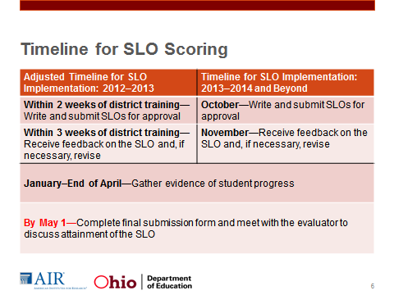
Slide 7
The SLO score is based on the percentage of students that met their growth target. The percentage then falls into one of five categories: Most Effective (5), Above Average (4), Average (3), Approaching Average (2), and Least Effective (1).”
These numerical ratings will then be combined with other student growth measures in the system to arrive at a final rating.

Slide 8
Consider, for example, a teacher who has 100 students in his or her SLO. If 90 of those students meet the growth target and 10 don’t quite reach it, this means 90 percent met the target, which is the threshold for the rating of Most Effective, or 5.

Slide 9  Now we’ll move into discussing how to prepare for the final scoring process. Again, this will occur at the end of the interval of instruction. In general, something to remember is that much of the onus of preparing the evidence of whether students met their targets or not does falls on the teacher. To make this review process possible, it is helpful to follow these steps exactly so that every time an evaluator or local committee is looking at this evidence from one teacher to another, they know exactly what they are looking at because it is organized in the same way. The more streamlined the process, the more likely it is both efficient and fair. | 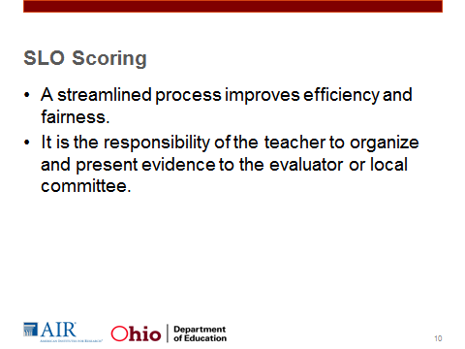
Slide 10  There are several documents that the teacher should have ready in order to present the evidence for review. The evidence should include:  - A copy of the original, approved SLO template and checklist for reference.  - The completed Individual SLO Scoring Template, which we’ll review in a moment.  - Copies of the student assessments on which attainment of the growth targets was measured (not completed student versions, just the assessments themselves),  - An explanation of how the assessment was scored. For example, if multiple assessments were used, detail how the scores of the assessments were combined to arrive at the final score. If any rubrics were used, provide copies. If team scoring was used, describe that process.” | 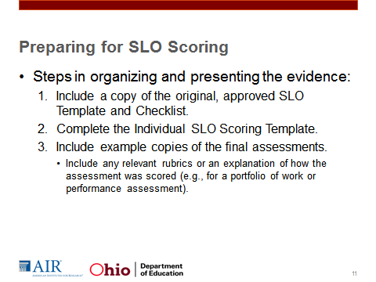
Slide 11  Say:  “After the final assessment has been administered and results are available, the teacher will complete the Individual SLO Scoring Template to present the evidence on growth target attainment for each student. The Ohio Department of Education (ODE) provides this document on its website. You have a screenshot of the Individual SLO Scoring Template and the SLO Scoring Matrix in Handout 4.1, but let me show you where to access the actual form on the ODE website.”  Click the hyperlink and show people where to find the document entitled “SLO Scoring Template.” Open up the form.  “This template will help you do the simple calculations involved in arriving at the final score, but its main purpose, really, is to present this information in a standardized way from one teacher to the next. Handout 4.2 contains directions on how to complete the template.”  Briefly summarize the contents of the table, noting that the teacher would fill in the first four columns when setting the SLO and then would just have to complete the final two columns towards the end of the interval of instruction.  “Once you have completed the Individual SLO Scoring Template, analyze the data. This completed template can be used to think about changes in practice and instructional strategies that might be used in the future to reach any identified groups of students who did not meet their growth targets.”  Scroll down to the second page of the document to show where the scoring information would go. | 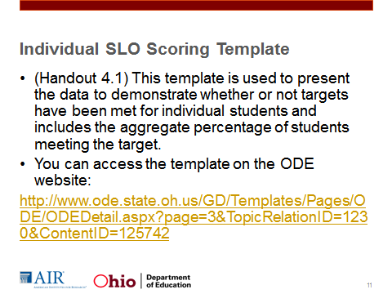
Slide 12  Plan to spend 15-20 minutes on slides 12–14.  Say:  “Here is an example scoring example. Ms. Montenegro is a second grade teacher at Sunny Elementary. Her SLO is focusing on writing and her assessment is a student portfolio of work.”  “We see here that Ms. Montenegro has listed the student name and student IDs listed for five students in the first two columns. In the third column, she has listed the baseline score, which in this case are results from a writing portfolio from the previous year. The fourth column contains the growth targets.”Most likely Ms. Montenegro filled out the first four columns of the chart when she created her SLO.”  “The fifth column lists the final assessment score that the student attained. In the final column, she noted whether the objective was me tor not, by determining comparing the final score to the growth target.  “Realistically, a teacher would most likely have more than 5 students. However, based upon this example, what percentage of students met or exceeded their growth target and what would her ratings be?”  Pause for a moment to let people think about it. Click the mouse so that the bottom of the chart appears.  “In this case, 60 percent of students met their growth target. The descriptive rating would be approaching average and the numerical rating would be 2.”  Ask the group if there are questions on the process, including what data should be entered into each cell. | 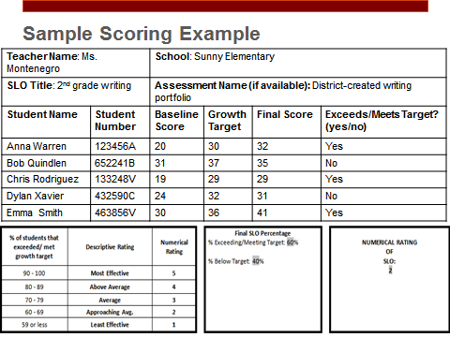
Slide 13
Once the teacher has gathered the necessary information for scoring, the teacher should meet with the evaluator to discuss SLO attainment. During this meeting, the teacher and evaluator should score the SLO. In addition, the teacher and evaluator should discuss how factors may have impacted SLO attainment and discuss how the teacher can improve his or her practice next year. This meeting can be part of a larger discussion about student growth.
Slide 15  In order to provide a consistent process for student growth measure scoring and minimize the burden on local education agencies (LEAs), each LEA will enter teacher scores within the Ohio Teacher and Principal Evaluation System (eTPES), which will then automatically record and calculate overall scores. The district plan will already be submitted in eTPES, which will have provided the default percentages for how much of the final score will be attributed to different types of student growth measures based on the three categories of teachers: A, B, and C. | 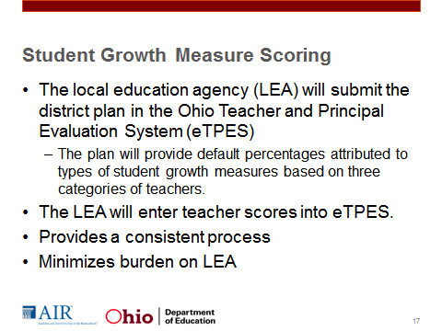
Slide 17  In some cases, districts may need to adjust the percentage attributed to each student growth measure for groups of teachers within a category due to unusual circumstances. Ideally, any variations would be made at the beginning of the year when the district plan is submitted in the system.  For example, it may be the case that a teacher only has one year of value-added data, and the evaluator or committee feels it would be appropriate to shift more of a percentage of the evaluation onto LEA measures. In this scenario, consistency in variations should be maintained based on circumstance. | 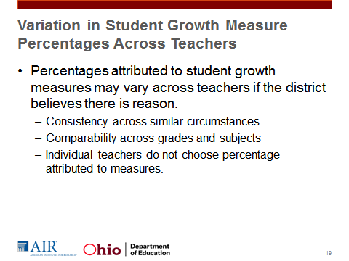
Slide 18  This worksheet represents the scores that will be entered for each teacher. Similar to the district plan we just saw, it includes four columns.  See Handout 4.4 for an easier-to-read version of this worksheet.  Value-added data and percentages allocated to each measure from the district plan will already be populated in the system.  The greyed-out boxes will be pre-populated by the system. The value-added and shared attribution scores will be entered in eTPES by the state for the districts. LEAs will also have already entered the weights for each measure through their district plan, which is why the two rows towards the bottom of the worksheet also appear in grey. The LEA will be responsible for entering the scores for each vendor assessment and SLO that applies to the teacher’s evaluation. An LEA representative is responsible for entering the numerical rating (1-5) for each vendor assessment and/or SLO.  Note that each teacher can incorporate up to five vendor assessments and six LEA measures (five SLOs and a shared attribution measure) if those measures are available. So, a teacher who did not have value-added or vendor assessments available could submit up to five SLOs in the system.  However, all measures within each of these three categories would be weighted equally in the system. For example, all five SLOs would receive the same weight.” | 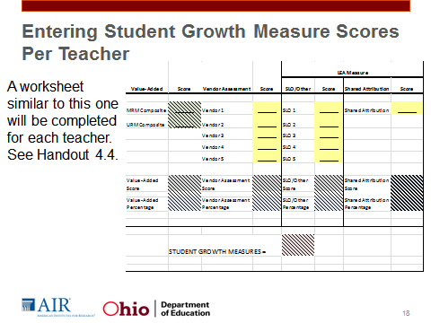
Slide 19  The final student growth measure score will be calculated by the eTPES system. The calculation used to arrive at this score is still being finalized and will be approved by the student growth measures advisory committee soon. The final SGM score will be converted into a rating of Above, Expected, or Below. We know that this still leaves some ambiguity about how the final SGM score will be calculated, but there will be additional materials available online that detail this process once it is approved. | 